Face Detector in Python with OpenCV
Instruction
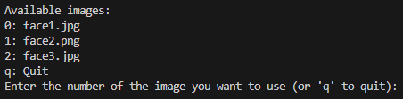
- Run the python code:

- Choose the image from folder:

